Slovenski etnografski muzej
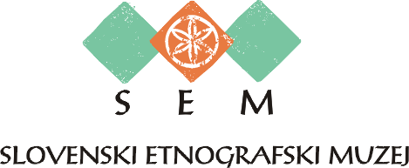
Metelkova 2
1000 Ljubljana
T (01) 300 87 00
F (01) 300 87 36
www.etno-muzej.si

VLOGA za ogled gradiva

Ime in priimek _____________________________________________________________________

Naslov ___________________________________________________________________________

Številka osebnega dokumenta ________________________________________________________

E-naslov __________________________________________ Tel. ____________________________

Povpraševanje po naslednjem gradivu / podatkih:
___________________________________________________________________________________________________________________________________________________________________________________________________________________________________________________________________________________

Namen uporabe gradiva / podatkov:
___________________________________________________________________________________________________________________________________________________________________________________________________________________________________________________________________________________

Ljubljana, Podpis:

