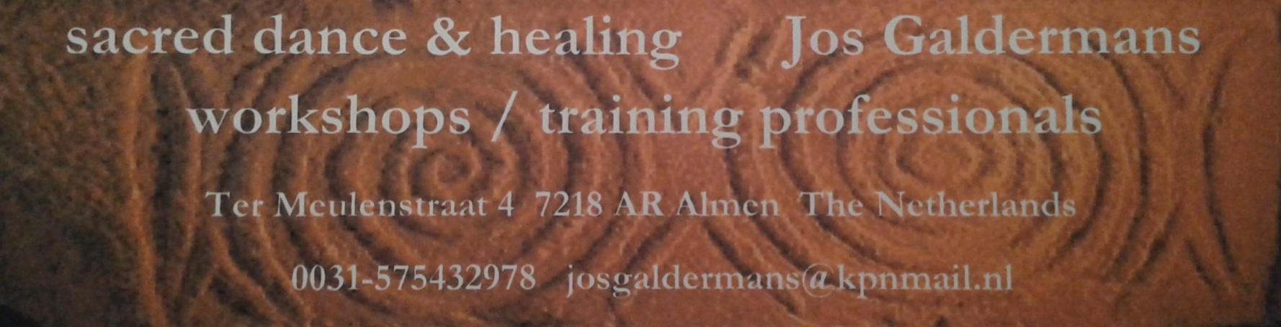

What is sacred dance ?
The combination of spirituality and dance is timeless. In all cultures and through all the ages people have danced to express their relationship with the mysteries of life and death, the gods, the inner source. In temple dances and in some old folkloristic dances this can still be found, but also in more recent, special choreographies. The ‘founding father’ of this contemporary form of dance meditation is Bernhard Wosien (Germany 1908-1986).

He was a professional ballet dancer and later in his life later became a dance pedagogue and choreographer. He was deeply interested in the relationship between dance and spirituality. He made an intensive study of traditional European (mostly Balkan, Greek and Russian)dance traditions and their background and started to give workshops in various European countries, offering a mix of old folklore dances (sometimes adapted by himself) and new choreographies that he made.

Two of his top pupils, after being thoroughly trained by him, set up an institute in Holland, according to Bernhard’s ideas, to train students to become professional sacred dance facilitators. Jos (Dutch: short for Joseph) received his diploma in 1991, after an intensive three-year study. Since then, he gives workshops, retreats and dance holidays throughout Europe.

From the participants he often gets back that they love the beautiful music, the gracious movements, the often mandala like patterns danced, the experience of togetherness in the moving circle and of course the joy of dancing, but mostly that they love to practice sacred dancing because it brings them into contact with their deepest layers, where their deepest strings are touched and where they can experience oneness and stillness.

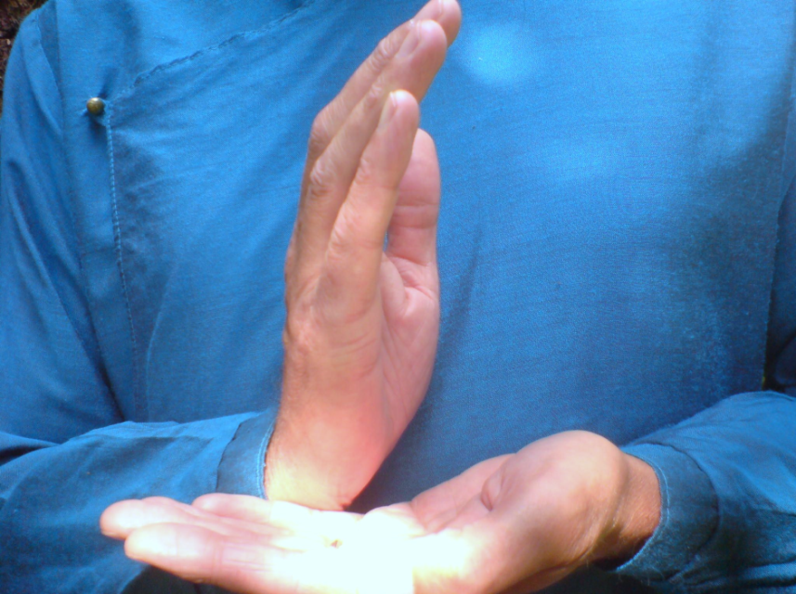
About Jos
Jos on his first experience of sacred dance, back in 1980: “It was like being struck by lightning; something resonated deeply in me. It was as if I had always known this, but had somehow forgotten....something ancient and at the same time timeless. It felt like coming home and I knew…I want to have much more of this”.

As any teacher can’t help colouring with his own being and energy the thing he teaches, Jos is mainly triggered by the healing qualities Sacred Dance can have. He focuses especially on body awareness and energy patters to help to transform energy. His ‘goal’ is not so much to become perfect technical ‘performers’ but to become as best we can a moving vessel for healing energies, for ourselves, for others, for the world, for the earth, for all that is...

“I think that in other times I might have become (and probably have been...) a priest, but in this
life becoming a therapist in natural medicine and a facilitator in Sacred Dance seemed the
proper way to contribute to the healing of body and soul and to help develop our finest and
most subtle energies”.

What to expect from the workshops ?
The most important in all workshops is: it is all about opening, stimulating, cleansing and refining the energy of the heart. The emphasis will be on experiencing the dances. Most of them will be fairly easy choreographies.
Every workshop can be experienced separately. Although it is advisable to participate in more workshops (as you profit from previous experience) you are also very welcome if you can join us for just one workshop.
Please note that everyone is welcome in the dance circle. There is always a lovely mix of participants with and without experience in this kind of meditative circle dance. No dance experience or special dance qualities are required.

What to wear.....
Please wear the clothes you feel comfortable in. You should be able to move freely. As we sometimes are very still and moving very little and sometime quite active, it is advised to have ‘layers’ of clothes so you can easily adapt to changes in temperature.

Some people like to dance on bare feet, some on special dancing shoes, some on socks, some on normal shoes. In any case: it is advised to have low heels and no anti slip soles (because it makes it almost impossible to do sudden turns on the spot and might cause knee damage). The wooden floor of the seminar room of the Ethnographic museum is perfect for dancing. Do not hesitate to bring various options, so you can see for yourself what works best for you.

Program 9/11/2016
- Introducing the speaker

- Sacred dance, a definition

- Historical view

- What does sacred dance have to offer and to whom?

- Healing aspect of sacred dance

- Sacred Dance in Slovenia and other countries

- Latest developments

- Questions and answers

- After the break: sacred dance in practice!

