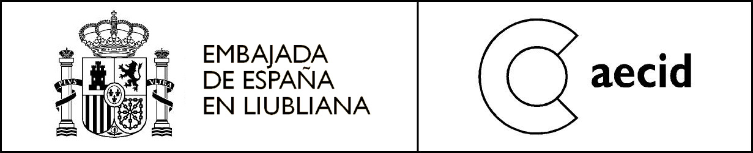

Exhibition, Spain

THIS IS NOT A MUSEUM. Mobile Devices Lurking
ESTO NO ES UN MUSEO. Artefactos móviles al acecho
Slovene Ethnographic Museum, 14 May – 17 June 2012

The exhibition THIS IS NOT A MUSEUM. Mobile Devices Lurking is produced by the ACVic Center for Contemporary Arts in Barcelona and staged at the

Slovene Ethnographic Museum in Ljubljana under the auspices of the Embassy of Spain.

It is part of a larger project “Ceci n’est pas une voiture”, which brings together research, education, and raising the awareness of the values and ideas of a travelling museum, the show is about transcending the boundaries of the museum and usurping the logic of its walls with mobile constructions and devices, a practice with a long tradition, including Marcel Duchamp’s famous Boîte-en-valise (1941). The exhibition aims to encourage a different concept of the traditional museum through portable structures, such as the Serpentine Gallery temporary pavilions since 2000, the Temporary Guggenheim project in Tokyo in 2001 and – the latest and best known – the Chanel Contemporary Art Container, conceived by Zaha Hadid in 2008. The exhibition curator is Martí Perán.
The exhibition is presented in the form of an information archive of individual cases. There is a selection of over fifty different mobile initiatives and strategies connecting and commenting on the museum context and the urban environment in numerous cities and countries. Also the local example, created during the workshop at MSUM
(7 – 14 May 2012) is included in the exhibition. Mentors of the workshop “Art, Social Space and Mobile Devices” were artists Domènec Monsterrat and Tadej Pogačar.

In Ljubljana the exhibition involves two Slovene national museums, the Slovene Ethnographic Museum and the Moderna galerija plus Museum of Contemporary Art Metelkova – MSUM, which, together with the National Museum of Slovenia, form part of the new museum complex Metelkova.

Workshop “Art, Social Space and Mobile Devices”, Museum of Contemporary Art Metelkova – MSUM, 7 – 14 May 2012
Public presentation of the workshop, Monday 14 May at 11 a.m., MSUM

More info: Laia Ros, laia.ros@maec.es
Adela Železnik, MG+MSUM, adela.zeleznik@mg-lj.si

This project was supported by:

